**BioData 16sw17**

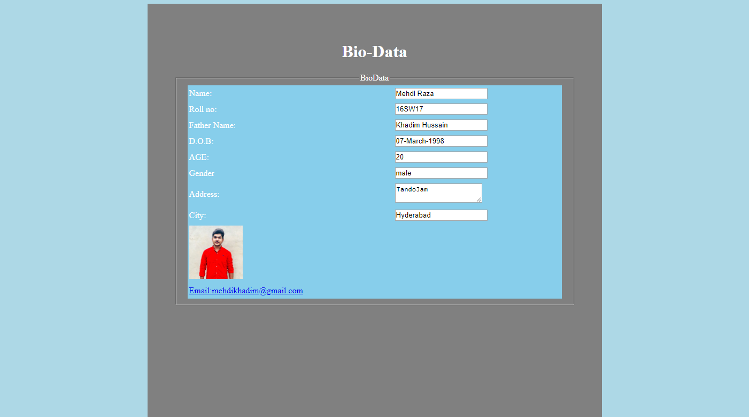

<!DOCTYPE html>

<html>

<head>

<title>

BioData

</title>

</head>

<body bgcolor="lightblue">

<div id="main" align="center">

<div id="container" style="width: 750px; height: 700px; background: skyblue; padding: 50px; color: white; background-color: grey ">

<h1 align="center" >Bio-Data</h1>

<FIELDSET>

<legend align="center">BioData </legend>

<table border="0" width="700" height="400" align="center" bgcolor="skyblue" >

<tr><td>Name:</td>

<td><input type="text" value="Mehdi Raza"></td>

</tr>

<tr> <td>Roll no:</td>

<td><input type="text" value="16SW17"></td>

</tr>

<tr><td>Father Name:</td>

<td><input type="text" value="Khadim Hussain"></td>

</tr>

<tr><td>D.O.B:</td>

<td><input type="text" value="07-March-1998"></td>

</tr>

<tr><td>AGE:</td>

<td><input type="number" value="20"></td>

</tr>

<tr><td>Gender</td>

<td>

<input type="text" name="Gender" value="male" >

</td>

</tr>

<tr><td>Address:</td>

<td><textarea>TandoJam</textarea></td></tr>

<tr><td>City:</td>

<td><input type="text" value="Hyderabad"></td>

</tr>

<tr><td><img src="ye.jpg" height="100" width="100"></td> </tr>

<tr><td><a href="mehdikhadim@gmail.com">Email:mehdikhadim@gmail.com</a></td> </tr>

</table>

</FIELDSET>

</div>

</div>

</body>

</html>